# Web design Cat 2: HOME DECOR

# Course: Web design AIIQ 2112

### Group Members:- Admission Number

### 1. Lewis Kariuki- AIIM/00477/2021

### 2. Beatrice Kambo - AIIM/00761/2022

### 3. Lucy Wanjeri - AIIM/00753/2022

link to our website:- <https://kenjin32icon.github.io/homedecor.github.io/>

HOME DECOR WEBSITE SCREENSHOTS

- Image 1

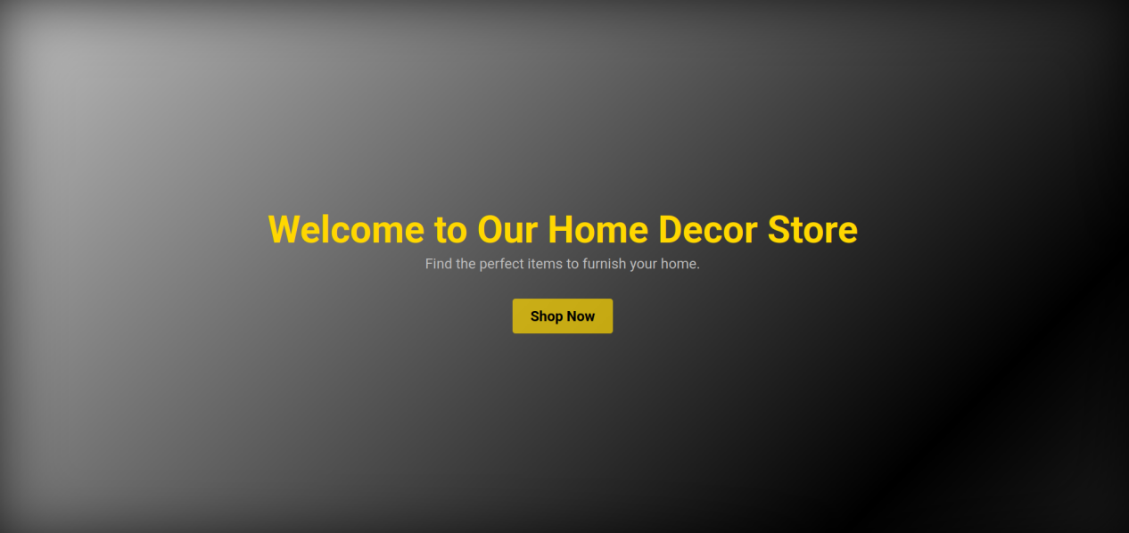

- Image 2

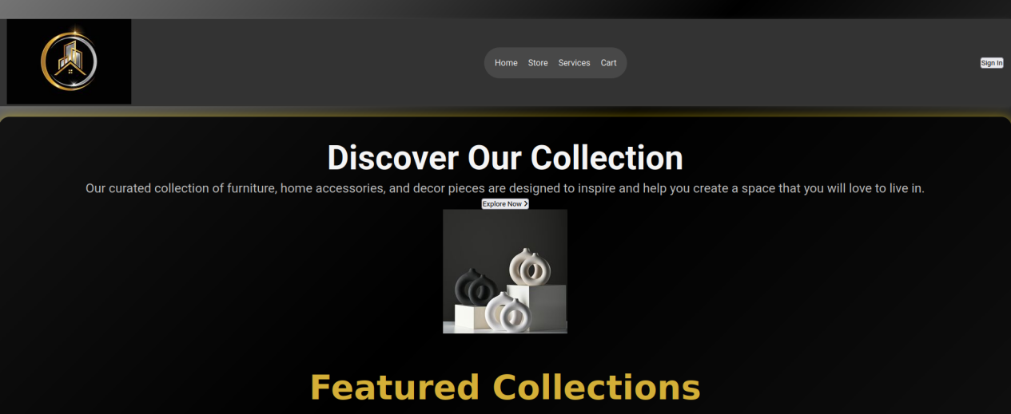

- Image 3

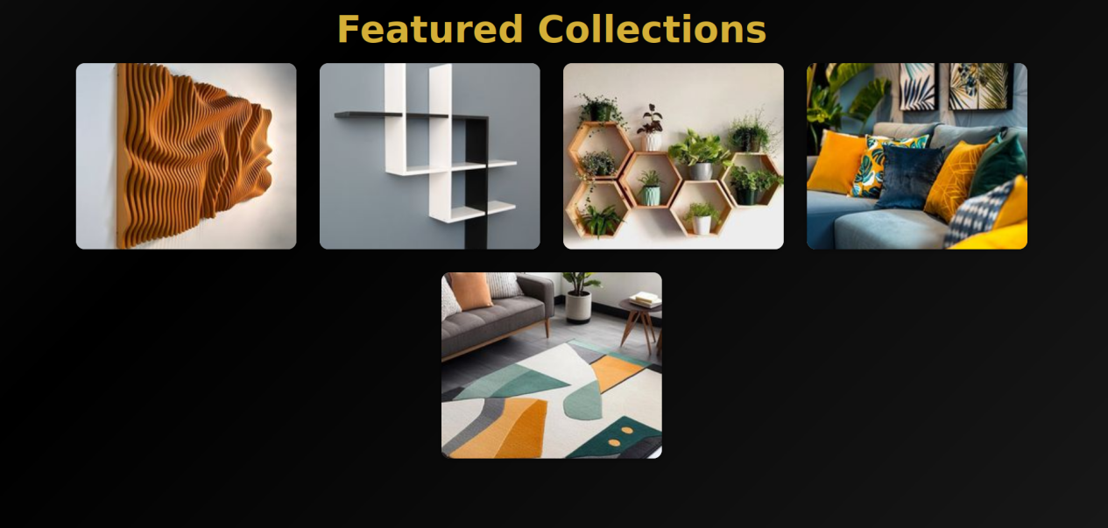

-image 4



HOME DECOR HTML/INTERNAL CSS CODE

```html

<!DOCTYPE html>

<html lang="en">

<head>

<meta charset="UTF-8">

<meta name="viewport" content="width=device-width, initial-scale=1.0">

<title>Home Decor Store</title>

<link href="https://fonts.googleapis.com/css2?family=Roboto:wght@300;400;700&display=swap" rel="stylesheet">

<link rel="stylesheet" href="https://cdnjs.cloudflare.com/ajax/libs/font-awesome/6.5.2/css/all.min.css">

<style>

:root {

--background-color: #000; /* Black background */

--text-color: #f5f5f5; /* Light text color */

--button-color: #d4af37; /* Gold color */

--footer-background: #333; /* Dark gray for footer */

--primary-color: #c0c0c0; /* Silver color */

--hover-color: #b8860b; /* Darker gold for hover effects */

}

* {

text-decoration: none;

padding: 0;

margin: 0;

box-sizing: border-box;

font-family: "Roboto", sans-serif;

}

body {

background: linear-gradient(135deg, #C0C0C0, #000, #808080); /* Gradient background */

color: var(--text-color);

}

/* Header styles */

.header {

height: 100vh;

display: flex;

flex-direction: column;

justify-content: center;

align-items: center; /* Center content horizontally */

padding: 20px; /* Add padding */

box-shadow: inset 0 0 100px rgba(0, 0, 0, 0.8); /* Dark shadow for depth */

}

/* Overlay for text readability */

.overlay {

text-align: center; /* Center text */

color: #FFD700; /* Gold color for text */

}

/* Content styles */

.content {

background-color: rgba(0, 0, 0, 0.8); /* Darker background for content */

padding: 40px;

border-radius: 20px;

box-shadow: 0 0 20px rgba(255, 215, 0, 0.5); /* Gold shadow for depth */

margin: 20px 0; /* Margin for spacing */

text-align: center; /* Align text to the left */

}

h1 {

font-size: 4em; /* Large header text */

margin: 0;

}

h2 {

font-size: 2.5em; /* Enlarged subheader */

margin-bottom: 10px;

color: #FFD700; /* Gold color for subheaders */

}

p {

font-size: 1.5em; /* Enlarged paragraph text */

margin: 5px 0;

color: #C0C0C0; /* Silver color for paragraph text */

}

/* Next section button */

.next-section-button {

padding: 15px 30px;

background-color: rgba(255, 215, 0, 0.7); /* Semi-transparent gold background */

color: #000; /* Black text for contrast */

text-decoration: none;

font-weight: bold;

font-size: 1.5em; /* Enlarged button text */

border-radius: 5px; /* Rounded corners */

transition: transform 0.3s ease, background-color 0.3s ease; /* Transition effects */

margin-top: 40px; /* Increased space above button */

}

.next-section-button:hover {

background-color: rgba(255, 215, 0, 1); /* Change background color on hover */

transform: scale(1.1); /* Enlarge the button on hover */

}

/* Styles for the second section */

#next-section {

padding: 20px; /* Add some padding for spacing */

}

/* Navbar styles */

.navbar {

padding: 0 15px;

background-color: var(--footer-background);

box-shadow: 0 2px 10px rgba(255, 255, 255, 0.1);

}

.navdiv {

display: flex;

align-items: center;

justify-content: space-between;

}

.navlinks {

background-color: rgba(255, 255, 255, 0.1);

border-radius: 99px;

display: flex;

align-items: center;

height: 59px;

padding: 0 20px;

}

.navlinks ul {

display: flex;

gap: 20px;

}

.navlinks ul li {

list-style: none;

}

.navlinks ul li a {

font-size: 16px;

color: var(--text-color);

transition: color 0.3s;

}

.navlinks ul li a:hover {

color: var(--hover-color);

}

.section2 {

margin: 60px auto 100px;

}

.items {

display: flex;

gap: 40px;

flex-wrap: wrap;

justify-content: center;

}

.item {

position: relative;

width: 380px;

height: 321px;

text-align: center;

transition: transform 0.3s;

background-color: var(--primary-color);

border-radius: 15px;

overflow: hidden;

box-shadow: 0 2px 10px rgba(0, 0, 0, 0.3);

}

.item:hover {

transform: scale(1.05);

}

.item img {

width: 100%;

height: 100%;

object-fit: cover;

border-radius: 15px 15px 0 0;

}

.item-description {

position: absolute;

bottom: 0;

left: 0;

right: 0;

background: rgba(0, 0, 0, 0.7);

color: #fff;

padding: 10px;

opacity: 0;

transition: opacity 0.3s;

}

.item:hover .item-description {

opacity: 1;

}

.section2 h1 {

text-align: center;

margin-bottom: 20px;

font-family: "Comfortaa", sans-serif;

color: var(--button-color);

}

.footer {

background-color: var(--footer-background);

width: 100%;

display: flex;

justify-content: center;

}

.footercontent {

display: flex;

gap: 57px;

margin: 40px 0;

}

.options ul {

list-style-type: none;

}

.subscribe {

background-color: var(--primary-color);

width: 374px;

border-radius: 99px;

display: flex;

justify-content: space-between;

margin-top: 27px;

}

.subscribe input {

border: none;

padding: 10px;

background-color: transparent;

color: var(--text-color);

}

.subscribe-btn {

border-radius: 0 25px 25px 0;

border: none;

background-color: var(--button-color);

color: var(--text-color);

cursor: pointer;

}

/* Responsive Styles */

@media (max-width: 768px) {

.item {

width: 90%; /* Full width for items on smaller screens */

max-width: 300px; /* Limit max width */

}

.footercontent {

flex-direction: column; /* Stack footer items */

align-items: center; /* Center footer items */

}

}

@media (max-width: 480px) {

.description h1 {

font-size: 40px; /* Smaller heading on very small screens */

}

button {

font-size: 16px; /* Smaller button text */

}

}

</style>

</head>

<body>

<div class="header">

<div class="overlay">

<h1>Welcome to Our Home Decor Store</h1>

<p>Find the perfect items to furnish your home.</p>

</div>

<a href="#next-section" class="next-section-button">Shop Now</a>

</div>

<div id="next-section">

</div>

<nav class="navbar">

<div class="navdiv">

<div class="logo">

<img src="https://i.pinimg.com/236x/64/6e/8f/646e8f9d632f2feaed09834b920eda7f.jpg" alt="Home Decor Logo">

</div>

<div class="navlinks">

<ul>

<li><a href="#">Home</a></li>

<li><a href="#">Store</a></li>

<li><a href="#">Services</a></li>

<li><a href="#">Cart</a></li>

</ul>

</div>

<div>

<button type="button">Sign In</button>

</div>

</div>

</nav>

<main class="content ">

<section class="section1">

<div class="description">

<h1>Discover Our Collection</h1>

<p>Our curated collection of furniture, home accessories, and decor pieces are designed to inspire and help you create a space that you will love to live in.</p>

<button type="button">

<span>Explore Now</span>

<i class="fa-solid fa-angle-right"></i>

</button>

</div>

<div class="image">

<img src="https://i.pinimg.com/236x/77/3e/c4/773ec427b917d56bafe44f996bf78cd8.jpg" alt="Nordic Vase">

</div>

</section>

<section class="section2">

<h1>Featured Collections</h1>

<div class="items">

<div class="item">

<img src="https://i.pinimg.com/236x/64/5c/6f/645c6f9eda32e4f7f5192dc350208b39.jpg" alt="3D Wall Decor">

<h3>3D Wall Decor</h3>

<div class="item-description">Add depth to your walls with this stunning 3D decor.</div>

</div>

<div class="item">

<img src="https://i.pinimg.com/236x/c5/7a/9f/c57a9fde392aad81913e7c83ee7de058.jpg" alt="Black and White Shelf">

<h3>Black and White Shelf</h3>

<div class="item-description">A stylish shelf that complements any decor style.</div>

</div>

<div class="item">

<img src="https://i.pinimg.com/236x/11/a9/91/11a991cf23f4ca0e860485542bb7aa78.jpg" alt="Floating Shelves">

<h3>Floating Shelves</h3>

<div class="item-description">Maximize your space with these elegant floating shelves.</div>

</div>

<div class="item">

<img src="https://i.pinimg.com/236x/14/94/3f/14943f34a571f4d0ddbc54eefd6ed3bf.jpg" alt="Decorative Throw Pillows">

<h3>Decorative Throw Pillows</h3>

<div class="item-description">Add comfort and style to your living space.</div>

</div>

<div class="item">

<img src="https://i.pinimg.com/236x/1c/af/41/1caf41f2e32af274114d34abae3d2ee6.jpg" alt="Stylish Rugs">

<h3>Stylish Rugs</h3>

<div class="item-description">Transform your floors with our beautiful rugs.</div>

</div>

</div>

</section>

</main>

<footer class="footer">

<div class="footercontent">

<div class="footer-item">

<div class="footer-logo">

<img src="https://via.placeholder.com/100" alt="Home Decor Logo">

</div>

<div class="socials">

<i class="fa-brands fa-whatsapp"></i>

<i class="fa-brands fa-instagram"></i>

<i class="fa-brands fa-x-twitter"></i>

<i class="fa-brands fa-facebook"></i>

</div>

</div>

<div class="footer-item">

<div class="item-title">

<h3>Quick Links</h3>

</div>

<div class="options">

<ul>

<li><a href="#">Shop</a></li>

<li><a href="#">Categories</a></li>

<li><a href="#">Inventory</a></li>

<li><a href="#">Offers & Discounts</a></li>

</ul>

</div>

</div>

<div class="footer-item">

<div class="item-title">

<h3>Contacts</h3>

</div>

<div class="options">

<ul>

<li>Phone1: <a href="tel:0746668098">0746668098</a></li>

<li>Phone2: <a href="tel:0722890506">0722890506</a></li>

< li>Email: <a href="mailto:homedecor@yahooo.com">homedecor@yahooo.com</a></li>

<li>Address1: NairobiCBD, Nairobi</li>

<li>Address2: Technical University of Kenya, TUK</li>

</ul>

</div>

</div>

<div class="footer-item">

<div class="item-title">

<h3>Newsletter Subscription</h3>

</div>

<div class="subscribe">

<input type="email" placeholder="Enter your email" required>

<button class="subscribe-btn" type="button">Subscribe</button>

</div>

</div>

</div>

</div>

</footer>

</body>

</html>

```